BIT 4107 – Mobile Application Development
ENHANCED PROFESSIONAL STUDENT LOGBOOK
Student Name: __Caleb Njuki_
Admission Number: __BIT/2024/55790___
School/Faculty: ___COMPUTING AND INFORMATICS____
Programme: _____BSCIT_____
Academic Year: ____YEAR III______
Semester: _____SEM II_________________________
Lecturer: _____Mr. Nyoro_________________________
Phone Number: ____0748389206_________

Instructions
This logbook is used to document weekly learning activities, practical exercises, skills acquired, challenges encountered, solutions applied, and reflections. Students should complete all sections every week.
Each week, follow the remarks in the week 1 section.

Autogenerated Table of Contents

Week 1: Introduction to Mobile Application Development

Practical Activities Undertaken
Basics of Mobile Application Development.
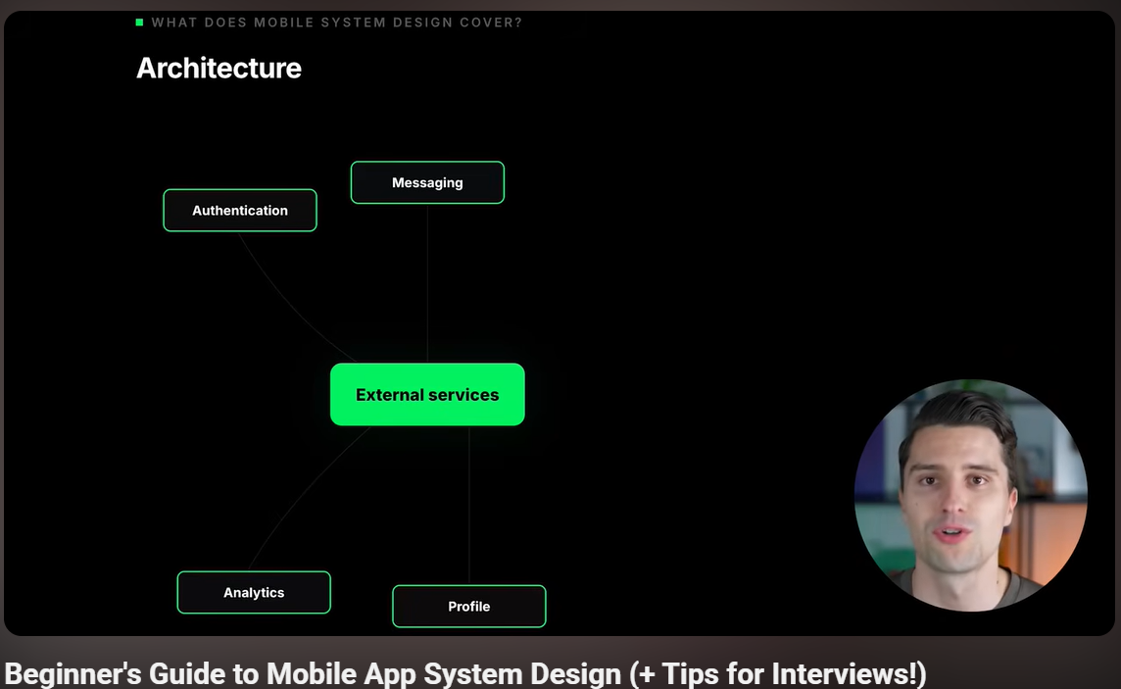
Video for Guide to Mobile App design for beginners. (Phillip Lackner)
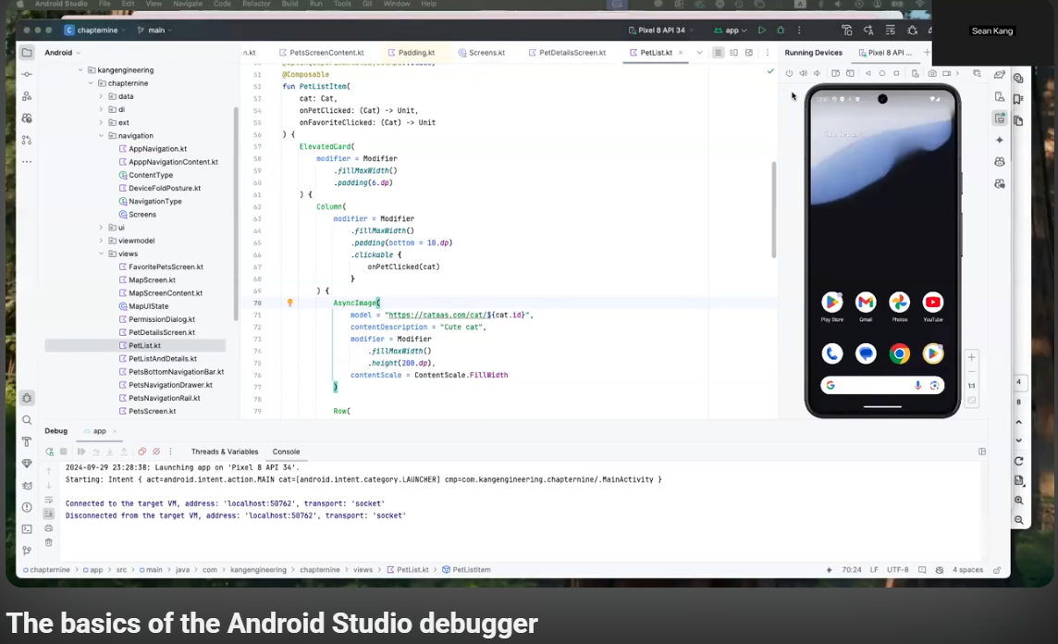
Video for Basic Android Studio Operations (Coding Diary)

Tools and Software Used
https://youtube.com

Personal Reflection
Android Studio is the best development app for Android apps, with all the requirements a developer needs. Newer versions have AI

WEEK 2: Mobile Development Environment

Practical Activities Undertaken
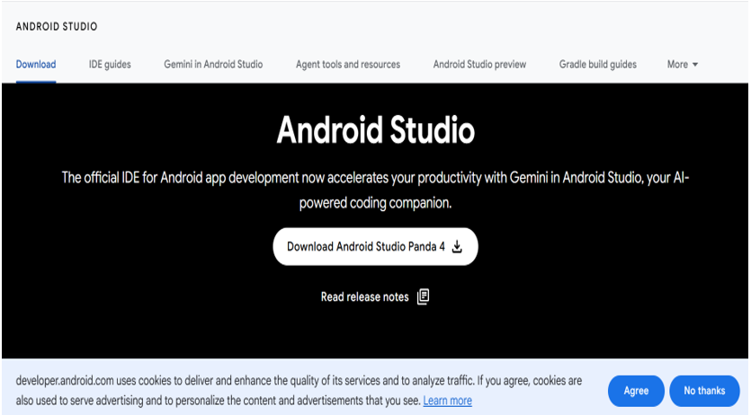
Image 1. Installation of Android Studio
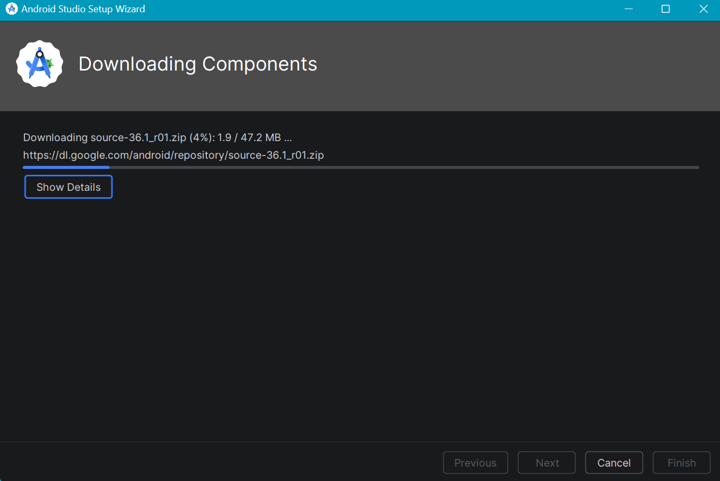
Image 2. Downloading default AS components
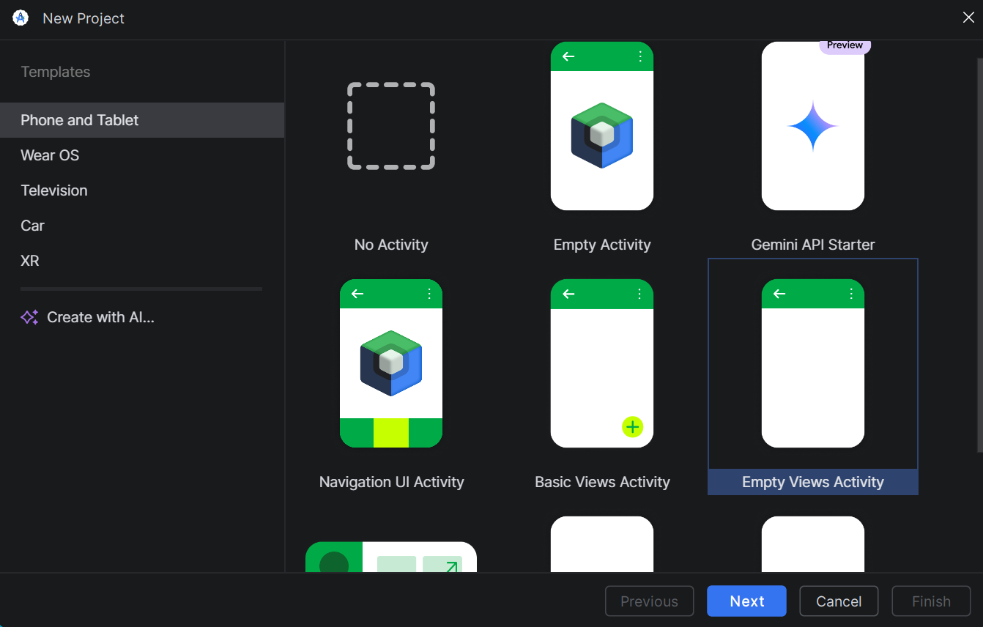
Image 3. Creating the project structure.
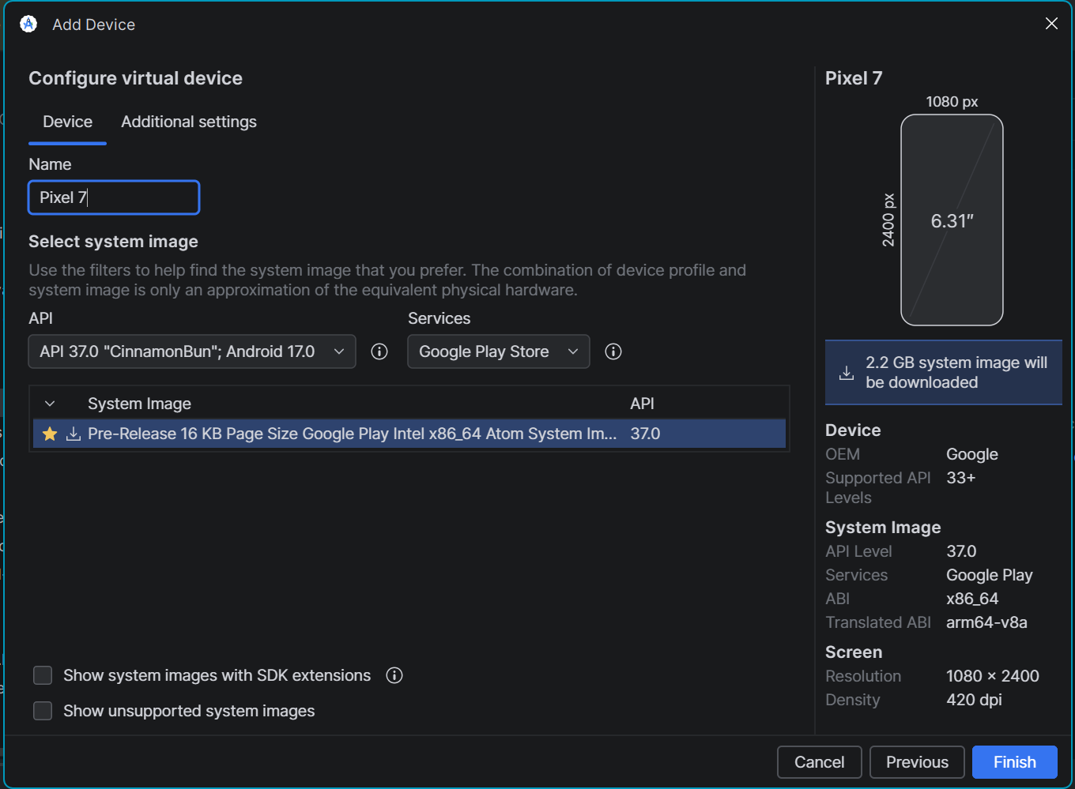
Image 4. Downloading the emulator

Tools/Software Used
- Browser: I used Google Chrome to install the Android Studio Panda 4 file.
- Android Studio

Personal Reflection
Everything ran smoothly without any challenges.

Week 3: User Interface Design

Practical Activities Undertaken
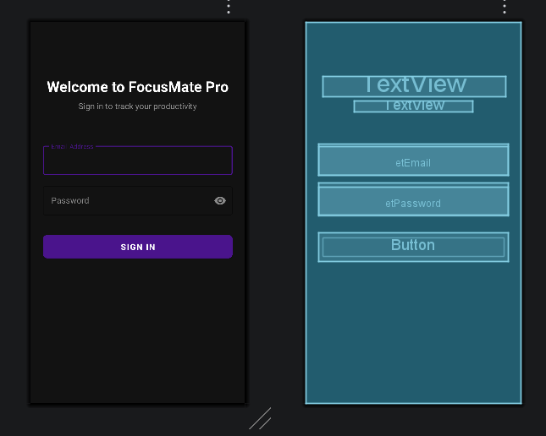
Image 1. First login screen for the app.
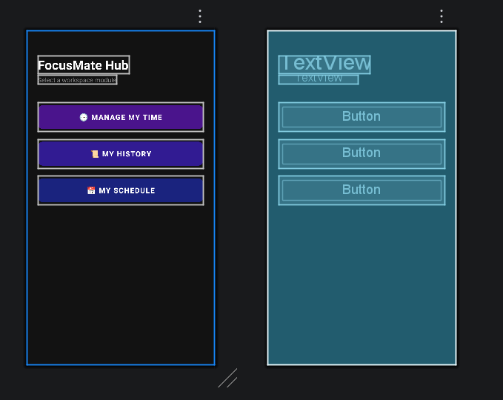

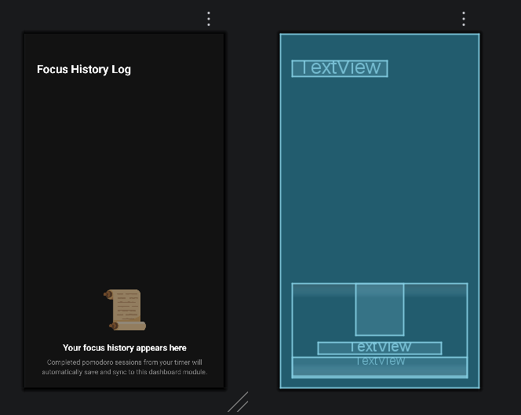
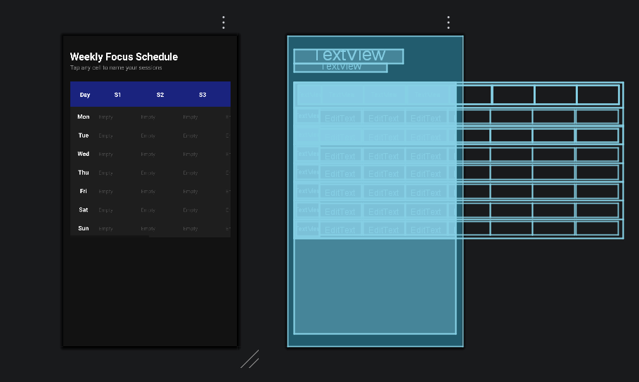

Image 2. XML-defined wireframes, and dashboard screens

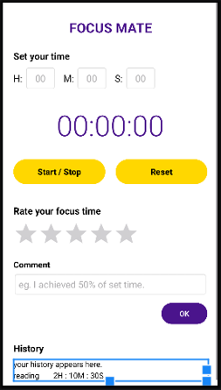
Image 3. Main UI

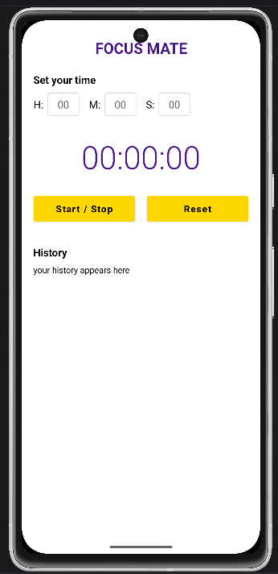
Image 4. Main UI successfully deployed to the Emulator
Tools and Software Used
Android Studio
Google

Personal Review
With XML code, creating a basic main UI was easy. This directly conceptualizes the wireframe design for UI.

Week 4: Event Handling and User Interaction

Practical Activities Undertaken
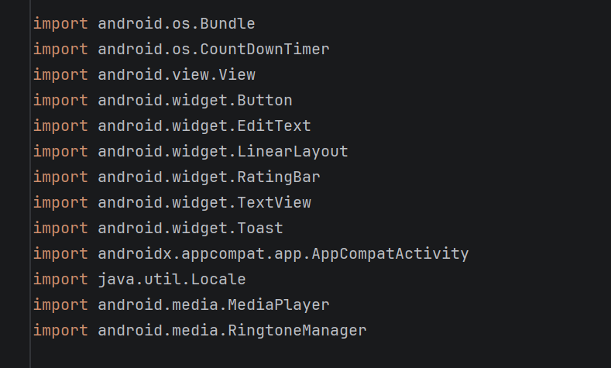
Image 1. Under the main activity file. Write the code that imports all the tools for all events of the app.
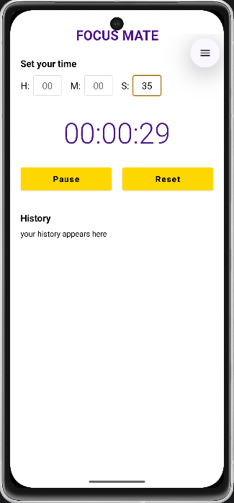
Image 2. First test of the timer counts down from 35 seconds
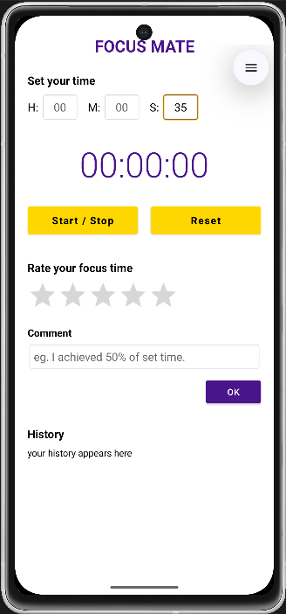
Image 3. New screen asking the user to rate their focus time.

Tools and Software Used.
Android Studio
Google

Personal Review
Individually, I was able to debug the code and deploy the first interactive UI on the emulator.

Week 5: Data Management

Same as week 1

Week 6: Networking and APIs

Same as week 1

Week 7: Application Architecture

Same as week 1

Week 8: Project Planning

Week 9: Device Features and Sensors

Same as week 1

Week 10: Notifications and Background Services

Same as week 1

Week 11: Mobile Security

Same as week 1

Week 12: Testing and Debugging

Same as week 1

Week 13: Application Deployment

Same as week 1

Week 14: Final Project Presentation

Same as week 1

Semester Project Tracking

Project Title

Project Objectives

Project Requirements

Development Milestones

Testing Results

Lessons Learned

Future Improvements

End of Semester Reflection

Summary of Skills Acquired

Most Interesting Topic

Major Challenges Faced

How Challenges Were Overcome

Professional Growth Achieved

Overall Course Experience

Final Approval
Student Name: ___Caleb Njuki_______________________
Student Signature: ______________________
Date: __8/6/2026_______________________________
Lecturer Name: ___Mr. Nyoro______________________
Lecturer Remarks: _____________________
Date: _________________________________

